NORTHVIEW MIDDLE SCHOOL
Metropolitan School District of Washington Township

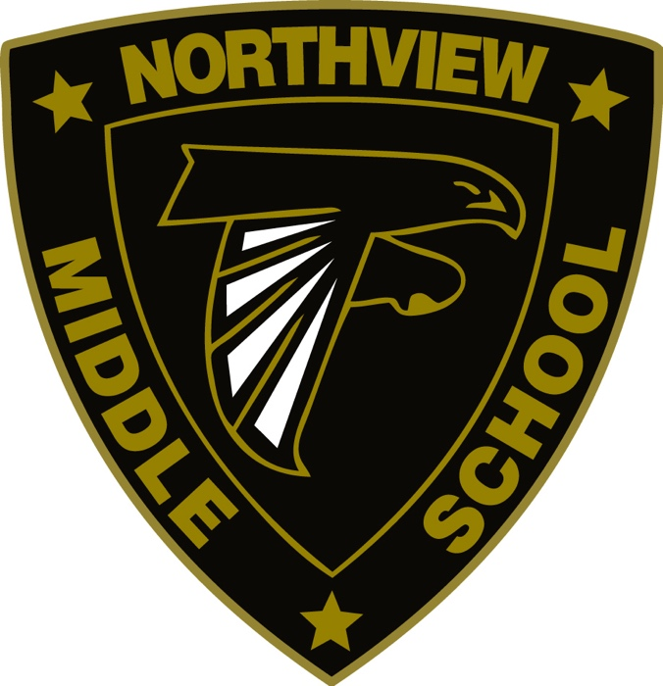

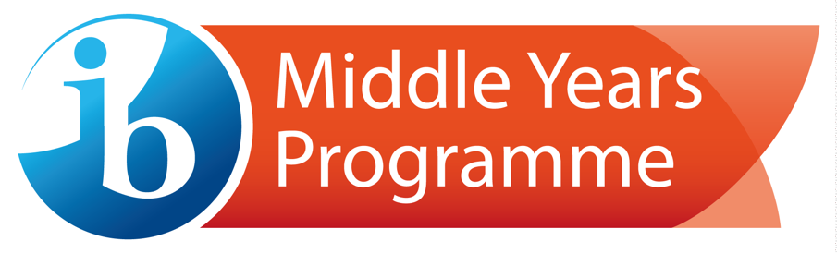

An IB World School
Guidebook

Innovative – Visionary – Inclusive – Diverse

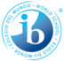

THE IB MISSION STATEMENT:
The International Baccalaureate aims to develop inquiring, knowledgeable and caring young people who help to create a better and more peaceful world through intercultural understanding and respect.

To this end the organization works with schools, governments and international organizations to develop challenging programs of international education and rigorous assessment.

These programs encourage students across the world to become active, compassionate and lifelong learners who understand that other people, with their differences, can also be right.

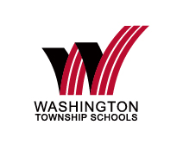

WASHINGTON TOWNSHIP’S MISSION STATEMENT:
The mission of Washington Township Schools is to develop life-long learners and globally minded citizens by fostering the academic, creative, and social skills needed to achieve excellence in a multi-cultural environment.

WASHINGTON TOWNSHIP’S VISION:
Superior schools in a supportive community.

MYP AT A GLANCE:
The Metropolitan School District of Washington Township is a fully authorized International Baccalaureate World School K-12 district. The Middle Years Program (MYP) at Northview Middle School offers a rich and rigorous curriculum that provides academic challenges transcending traditional subject areas and connecting with real world experiences. We focus to develop and growth of each student through the learner profile attributes and the approaches to learning. The MYP includes ALL students in grades sixth through ten creating a middle and high school partnership.

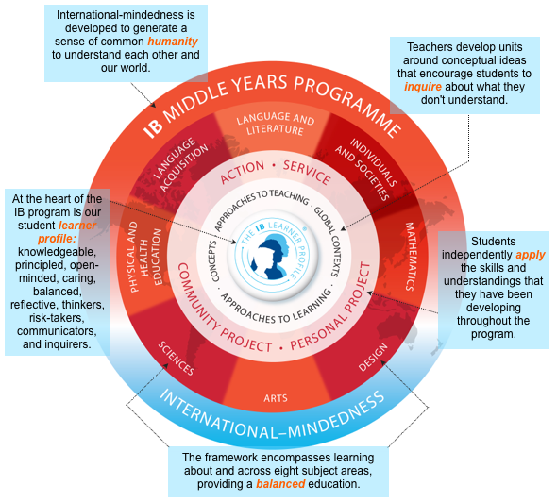

To read more, visit the district website at https://www.msdwt.k12.in.us/academic-programs/
Or the IB MYP at https://www.ibo.org/programmes/middle-years-programme/

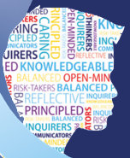
INTERNATIONAL MINDEDNESS: The Learner Profile
The aim of all IB programs is to develop internationally minded people who help to create a better and more peaceful world. IB wants students to recognize we are all human, and that we must share in caring for each other and our planet. The IB learner profile represents ten attributes valued by IB World Schools. These attributes, and others like them, can help individuals and groups become more responsible members of local, national, and global communities.

INQUIRERS
We nurture our curiosity, developing skills for inquiry and research. We know how to learn independently and with others. We learn with enthusiasm and sustain our love of learning throughout life.

KNOWLEDGEABLE
We develop and use conceptual understanding, exploring knowledge across a range of disciplines. We engage with issues and ideas that have local and global significance.

THINKERS
We use critical and creative thinking skills to analyze and take responsible action on complex problems. We exercise initiative in making reasoned, ethical decisions.

COMMUNICATORS
We express ourselves confidently and creatively in more than one language and in many ways. We collaborate effectively, listening carefully to the perspectives of other individuals and groups.

PRINCIPLED
We act with integrity and honesty, with a strong sense of fairness and justice, and with respect for the dignity and rights of people everywhere. We take responsibility for our actions and their consequences.

OPEN-MINDED
We critically appreciate our own cultures and personal histories, as well as the values and traditions of others. We seek and evaluate a range of points of view, and we are willing to grow from the experience.

CARING
We show empathy, compassion and respect We have a commitment to service, and we act to make a positive difference in the lives of others and in the world around us.

RISK-TAKERS
We approach uncertainty with forethought and determination; we work independently and cooperatively to explore new ideas and innovative strategies. We are resourceful and resilient in the face of challenges and change.

BALANCED
We understand the importance of balancing different aspects of our lives-intellectual, physical, and emotional-to achieve well-being for ourselves and others. We recognize our interdependence with other people and with the world in which we live.

REFLECTIVE
We thoughtfully consider the world and our own ideas and experience. We work to understand our strengths and weaknesses in order to support our learning and personal development.

IB AT SCHOOL:
Inquiry at the school looks different than a traditional classroom in a number of ways. Below are some of the highlights students will experience in an IB classroom.

- Foster a sense of community where essential agreements become guidelines for all teaching, learning and communication.
- Focus on international mindedness.
- Question and attempt to answer real world problems and issues.
- Collaborate and use hands-on approaches to solve problems.
- Create student-centered and inquiry-based learning.
- Construct understanding in the process of working and conversing with others.
- Provide opportunities for students to practice critical thinking.
- Engage and investigate interdisciplinary relationships.
- Celebrate diversity.

IB AT HOME:
As your child grows in their learning, opportunities to incorporate the IB philosophy at home. Here are a few ways to continue learning beyond the school.

- Promote the development of the Learner Profile.
- Discuss the impact of everyday actions on the world and its individuals.
- Provide opportunities for children to be curious about the world around them.
- Encourage children to ask deeper questions.
- Read and discuss events happening in our community and world.
- Provide opportunities for children to help at home and in the community.
- Celebrate family culture and traditions.
- Encourage children to become a teacher of their second language at home.
- Share personal experiences with your child about your career and experiences.

ASSESSMENTS AND GRADING:
Our students have had a special and unique opportunity to take part in the school-wide International Baccalaureate program. No other district in our city offers this for ALL students enrolled. IB MYP schools believe that teachers should grade students differently by using rubrics to help students understand their growth.

Below is the conversion chart that shows IB achievement levels (grades), percentages and letter grades. Once the project/assessment is graded using the rubric(s), your child will earn a score between 0 and 8. This chart will help you see the achievement level, percentage and letter grade all at once. End of the unit projects/assessments could be graded traditionally (percentages) or using the MYP criteria (achievement levels). Both are still being used as we transition to IB criterion-based grading.

IB ACHIEVEMENT LEVEL | WORD DESCRIPTOR | PERCENTAGE | LETTER GRADE
8 | Above and Beyond | 95-100 | A+ / A
7 | Superb | 90-94 | A-
6 | Excellent | 85-89 | B+ / B
5 | Very Good | 80-84 | B-
4 | Average (Mastery) | 75-79 | C+ / C
3 | Adequate | 70-74 | C-
2 | Limited Understanding | 65-69 | D+ / D
1 | Needs Improvement (Redo) | 60-64 | D-
0 | Unacceptable (Redo) | 0-59 | F

SERVICE LEARNING:
“IB learners strive to be caring members of the community who demonstrate a personal commitment to service, and act to make a positive difference to the lives of others and to the environment. IB World Schools value service with others as an important way to engage in principled action across a range of overlapping local and global communities.”
(MYP: From Principles to Practice p. 22)

The MYP program includes a student-initiated community service component that encourages students to extend their learning beyond the classroom. The action can involve service to their classmates or to the larger local and global community. Through such action, students develop skills such as cooperation, problem-solving, and conflict resolution that encourage thoughtful, active citizenship.

PERSONAL PROJECT:
As an International Baccalaureate World School, all tenth grade students participate, prepare and present projects on a variety of topics. This Personal Project topics are selected by the student and can encompass many areas of learning such as:
- learning to play a musical instrument,
- providing community service,
- developing potential solutions to school, community, state, national, or international issues,
- composing music,
- creating artwork,
- building shelters,
- building hand-made furniture,
- developing computer code.

Our students, faculty advisors, and community members connect to provide students with relevance to their education. Tenth graders meet regularly with their advisors to plan, prepare, research and explore their area of interest. The culmination of their projects are showcased in the spring of their tenth grade year.

POLICIES:
Academic Honesty Policy
Assessment Policy
Inclusion Policy
Language Policy

RESEARCH AND KEY FINDINGS:
“The Global Research department collaborates with universities and independent research organizations worldwide to produce rigorous students examining the impact and outcomes of the IB’s four programs. The findings come from IB-commissioned research relating to the MYP. Studies highlight a number of outcomes including:
- The skills fostered through the MYP
- Non-scholastic outcomes of the program
- The academic achievement of the MYP students.”
www.ibo.org/reserch

For more information regarding the research and outcomes of the data collected, visit
http://www.ibo.org/research

https://www.ibo.org/globalassets/publications/ib-research/myp-key-findings-en-updated.pdf

FREQUENTLY ASKED QUESTIONS:
To learn more about:

Frequently asked questions:
https://www.ibo.org/globalassets/digital-tookit/brochures/parent-pack-faqs-about-the-myp.pdf

An IB education in-depth:
What is an IB education?

IB and the Common Core State Standards (CCSS):
http://www.ibo.org/en/about-the-ib/the-ib-by-region/ib-americas/connecting-ib-to-the-common-core/

The Common Core State Standards Initiative:
http://www.corestandards.org/

If your questions aren’t answered here, please contact:
Karen Gouge, Northview IB Coordinator, at kgouge@msdwt.k12.in.us or by calling Northview at 317-259-5421.

